BARC TDRC Tube Bending In-Process Inspection

Tasks for Summer Quarter

# 06/05/19

* **Problem Statement:**
  + Improve process efficiency by integrating inspection to the production process.
  + Tube Bending is 25% of production time. Tube Inspection is 50% of production time.
  + Tubes defined by three measurements:
    - A: bend angle (focus for first step in project)
    - L: length between intersection points
    - R: rotation about mandrel axis
  + Assuming camera-based approach for bend angle measurement, capture images directly above bend, where tube has translated past bend die to avoid interference with tooling

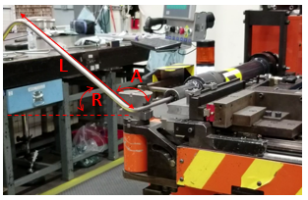

Figure : Measurements used to define tube geometry.

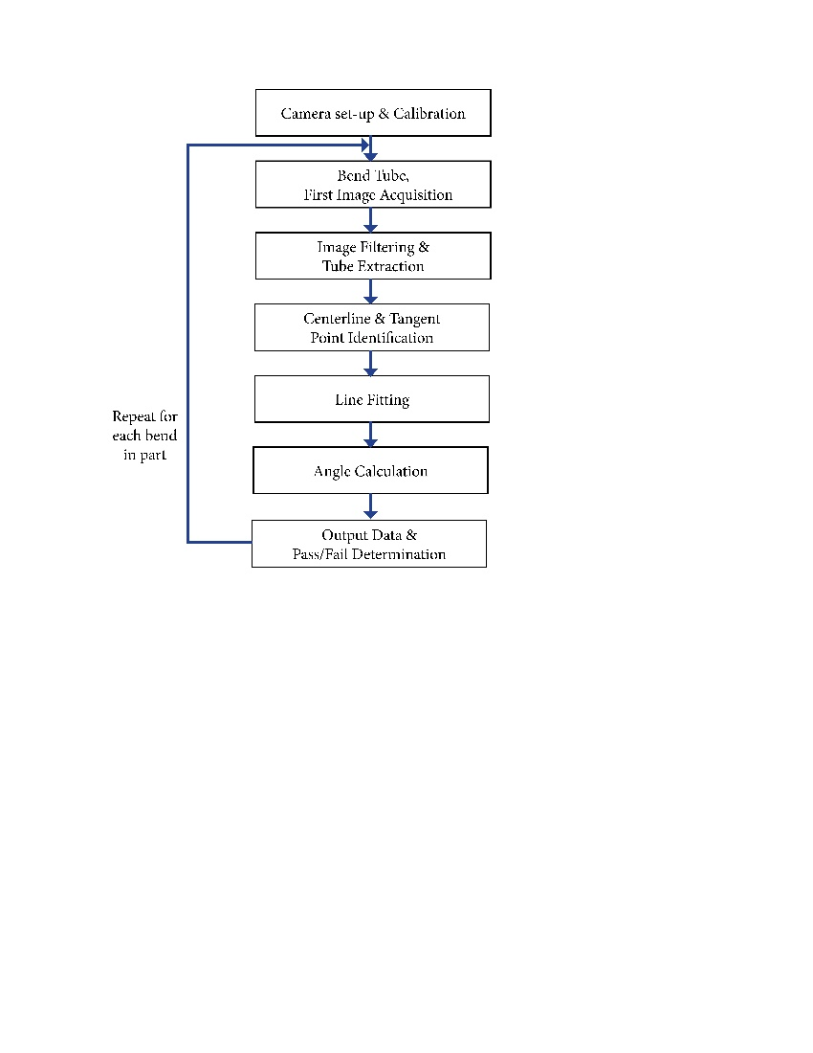

Figure : Image Processing Algorithm Sequence of Operations

* **Performance Requirements:**
  + Bend angle tolerance of 0.5⁰-1⁰
    - Target Measurement Precision: 0.05⁰-0.1⁰
  + Working Distance: varied from 24” – 72”
    - Based on input tube length, working distance of half the tube length
  + Camera Field of View: assume ~4”x~4” based on bend radius and minimum straight section between bends
* **Project Summer Quarter Deliverable:**
* Graduate Team
  + - Evaluation matrix comparing lighting, camera distance, background noise, one vs two cameras, orientation between camera and tube
    - Identify optimal camera working distance – shooting method varying camera from 24” – 72”
      * Compare loss of resolution with reduced parallax effect as camera distance increases
    - LED backlighting as baseline for image quality – determine change in accuracy as lighting is varied and background noise introduced
      * Backlighting vs Frontlighting
      * Camera filters
      * Replicate TDRC background

Figure : TDRC tube bending station as viewed from above.

* + - Use calibration artifacts measured with ATOS scanner for comparison with captured images and angle calculations
    - Further develop image processing
      * Tangent Point identification – iterative least squares
    - Consider adding a second camera for stereo-vision approach
      * Reduce effects of camera and tube being out of plane
    - Explore length & rotation measurement concepts
      * Addition of second camera
      * Potential of line scanner or 3D scanner
* Tube bending test bench (Cathy – BARC)
  + Combine controls to single platform (Labview)
  + Add mandrel translational/rotational movement
  + Modify camera set-up to minimum working distance of 30”
  + Baseline for tubes bent in BARC
    - ME CMM or TDRC ATOS?
* **Items for Chris to explore in Auburn:** 
  + Evaluate use of single ATOS scan/depth image, recreate 3D model based on cylindrical geometry
    - Potential to capture bend angle and rotation in one measurement
  + Test Keyence laser profiler for in-plane bend measurement
    - Compare with camera-based results
  + Further develop image processing algorithm
  + Evaluate integration approaches at TDRC work station